RECEIVING A GOLD MEDAL FROM HEALTH MINISTER BY RUPA 2017 B.PHARM

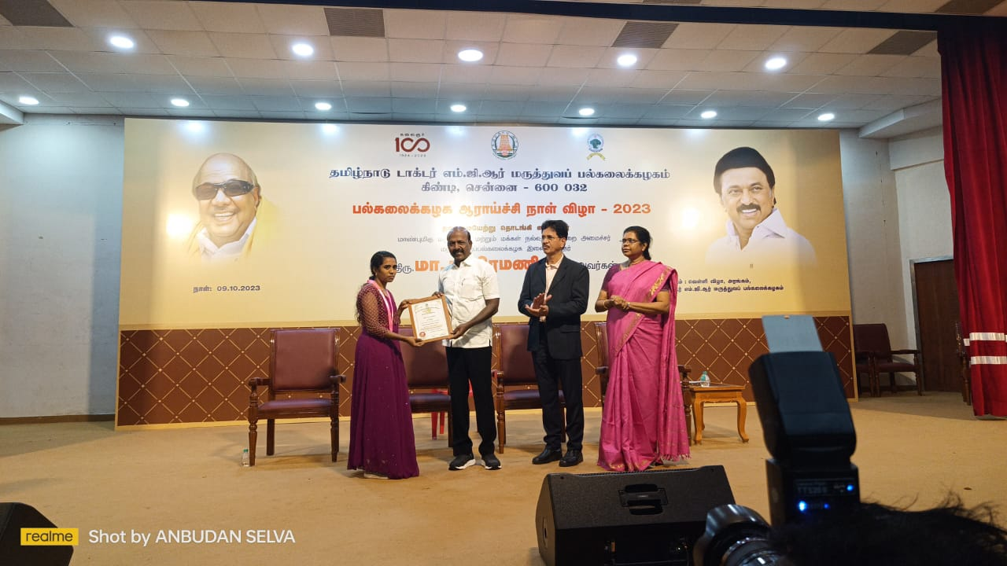

SECURING SECOND TOPPER IN THE TAMILNADU DR.M.G.R MEDICAL UNIVERSITY BY RUPA 2017 B.PHARM

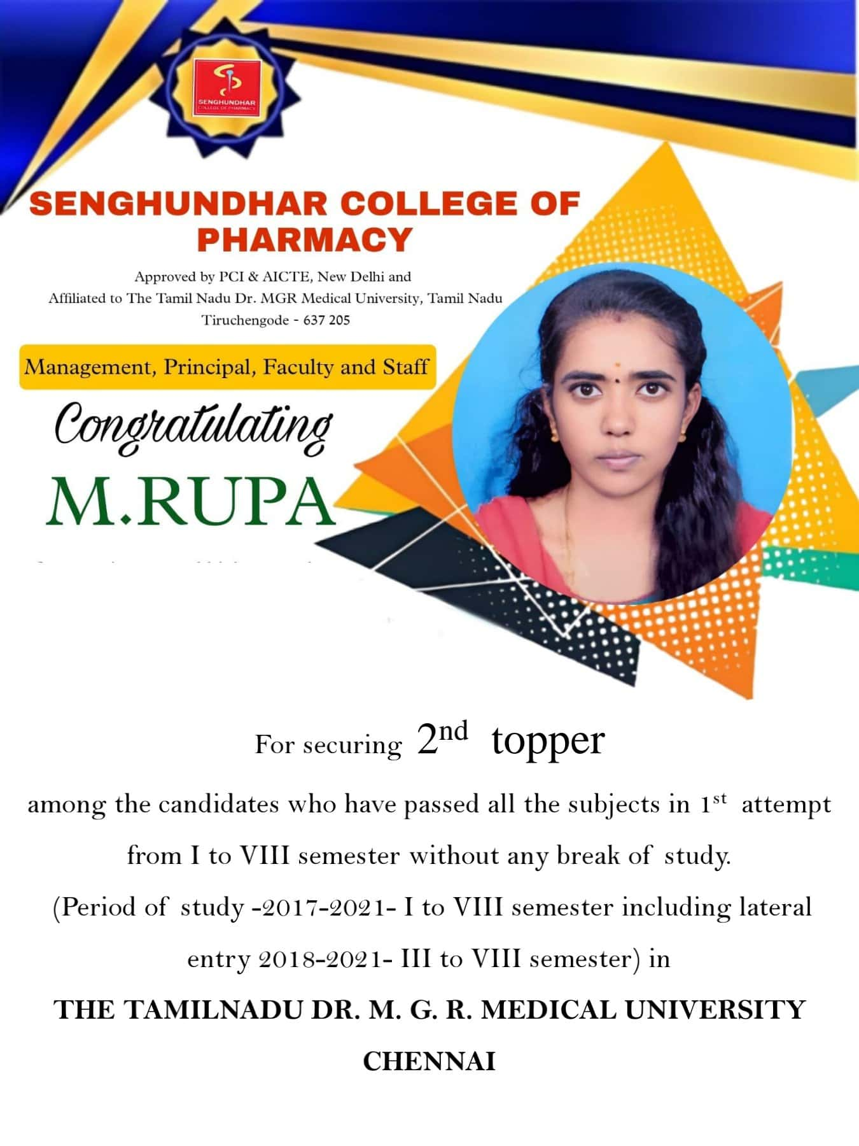

RECEIVING THE GOLD MEDAL FROM THE TAMILNADU DR.M.G.R MEDICAL UNIVERSITY

( 36 TH CONVECATION GOLD MEDAL SEVARATNA Dr.R.VENKATESALU GOLD MEDAL AND 36 TH  CONVECATION UNIVERSITY MEDAL).

